Concept of Youth Employment Initiative in Bangladesh

Introduction
Youth employment is a critical concern in Bangladesh, where young individuals often face challenges in securing income for their basic needs. Limited job opportunities, a lack of awareness on employment strategies, and high standards set by employers contribute to the difficulties faced by the youth. This leads to problems such as hopelessness and low self-esteem among young people. Recognizing the existing efforts of various NGOs in addressing youth employment, Woord en Daad has collaborated with a consortium of organizations to consolidate programs and create a sustainable and efficient approach. The participating organizations include:
- Fr. Charles J Young Foundation (FCJYF)
- Christian Service Society (CSS)
- Job Booster Social Bangladesh (JBSB)
- National Council of Churches of Bangladesh (NCCB)
- Stromme Foundation Bangladesh (SFB)
- The Leprosy Mission International Bangladesh (TLMIB)
- Woord en Daad (W&D)

Using the System Change Canvas, the consortium formulated a vision: “Youth of Bangladesh are empowered to access dignified employment to enjoy the fullness of life.” From this vision, they
developed the intervention named Job Booster, functioning as a Job Placement Facility. This facility, adaptable to various locations in Bangladesh, aims to complement existing programs of partner organizations.

Concept
The cornerstone of this concept is the market demand. So, the concept is developed based on what the market needs. Through a feasibility study, the promising sectors are identified and the types of jobs they could offer. Job Booster needs to connect the market demand with the available workforce. That means: consider who is available, whether they can start immediately, or if they need support. Job Booster should be a one-stop shop for employment & training. Employers can come here to find good people for their company. Young people can come here if they need help finding a job or setting up a business.

It's important for this initiative to be sustainable, able to continue without external funding. This has several benefits, such as quicker expansion to other regions, reduced dependency on insecure international donor funds, the initiative is rooted in the context of Bangladesh and not dependent on the preferences of the international donor community, there is a need for added value because of market relevance. The specifics of sustainability are still being worked out, but it could involve companies paying for qualified staff, young individuals contributing to their training and coaching, using Bangladeshi subsidies for education and training, and companies paying for the execution of CSR policies.

Sometimes, in certain areas where there aren't many job opportunities, we might focus more on helping people start their own businesses. In those places, Job Booster will be set up to mainly support self-

employment. For instance, the training provided will include not only job-specific skills but also develop a business plan, access to finance, marketing etc.

This entire approach will be carried out under the name "Job Booster."
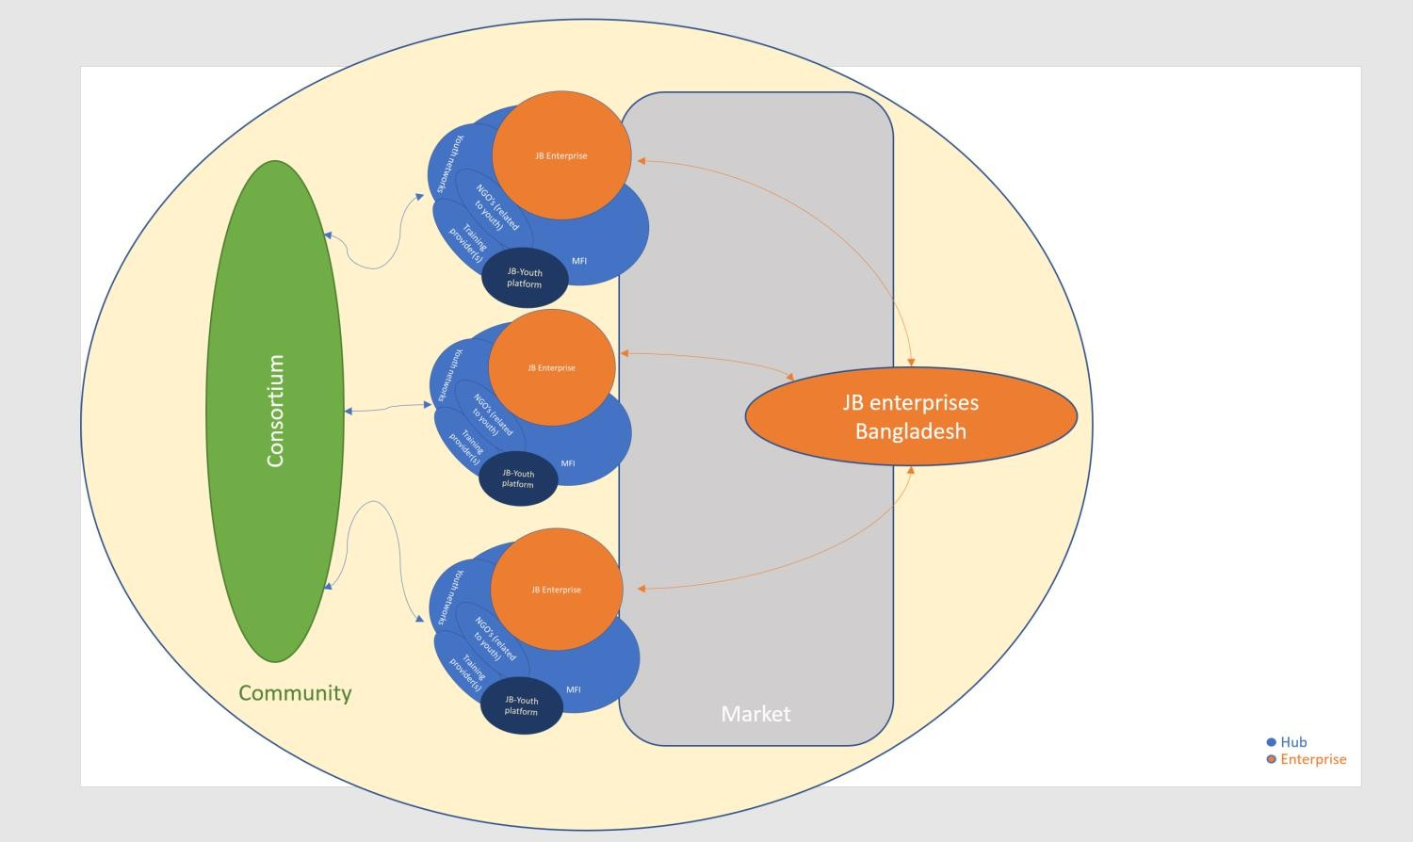
To ensure Job Booster is market-oriented, we've split it into two parts: Job Booster Enterprise and Job Booster Hub. Job Booster Enterprise focuses on representing the demand side and connecting with the supply side. Job Booster Hub mainly concentrates on the supply side, ensuring that the available workforce aligns well with the demand.

Graphical Representation of the Entire Concept

Compilation and services
The Job Booster hub can have different parts and services. What these parts are will be decided by the consortium partners after discussing the feasibility study. It's important that the Job Booster Hub connects well with youth and provides useful things for them. The split of services between the enterprise and the hub may also change during the further development of the concept. Here are some possible services for the Job Booster Hub:

- Training to provide young people the skills they need.
  - Long-term partnerships with training providers
  - CV writing and enhancement services
  - Offering basic training, including soft skills and values-based training
- Coaching: Support and advice for youth in their careers or when starting a business.
- Lobby and advocacy, bringing youth together in a youth network to give them a voice, This can also help make sure the hub meets the needs of youth.
- Access to finance through a Microfinance institution (MFI) to help the youth get money.
- One stop shop: Job Booster presents themselves in a platform where the youth can connect to the different actors or services
  - Creating an updated, searchable job seeker database
  - First-level screening of job candidates (qualified and skill-matched)
- Connection to community programs: NGOs that talk to the youth and can connect them with their programs.
  - Inclusion programs for individuals with disabilities
  - Inclusion programs for women.

The enterprise acts like a job expert, mainly focused on finding and hiring people. They represent the employers in Job Booster, making sure they find the right person for the available jobs. They do this in a financially sustainable way, with a mix of both blue-collar and white-collar job opportunities. Working closely with the Job Booster Hub is crucial for success, and each side has its own roles and responsibilities. Here are some possible services for the Enterprise:

  - Continuous market demand analysis
  - Long-term partnerships with employers
  - Translating requirements to the hub
  - Entrepreneurship and technical training
  - Branding and communication tools
  - Strengthening hub capacity
  - Multi-level candidate screening
  - Arranging worker replacements as needed.

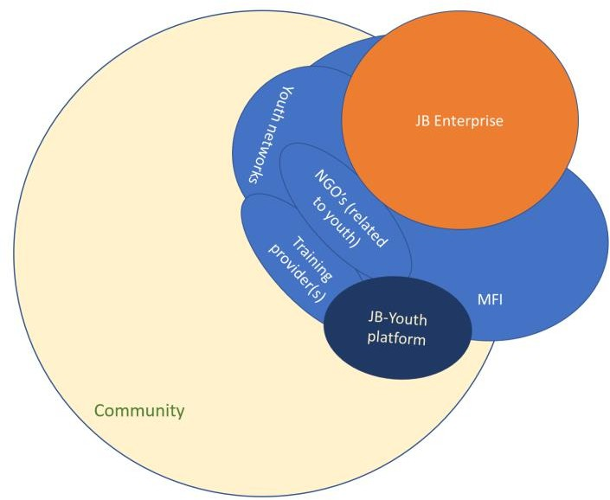

Compilation of the Job Booster Approach

Area and employment sector selection

Members selected three regions Dhaka, Khulna, and Rangpur. Employment sectors are selected by the members considering the recommendation of the feasibility study. The feasibility study was conducted by a consultation farm

within those three regions. Members also agreed to start the “Hub” immediately and introduce the “Enterprise”

afterward. Members also recommended hiring a Coordinator for the consortium to take it to the next level.

Name of region | Employment sectors
Dhaka | Security service, ICT, Caregivers, and Office attendants
Khulna | Security service, ICT, Caregivers, Office attendants, and handicrafts
Rangpur | Handicraft, Security service, and ICT

Potential Target Groups Identified by Region:
,
Dhaka (all ethnic groups included) | Khulna | Rangpur
- Less educated  - Class 5-12  - Manual works  - Willing to shift location  - Male and female  - Ages 18-35 (ages 22-30 ok)  - Educated unemployed  - Class 12+  - Uneducated  - No schooling  - Ages 18-35  - Cannot read nor write  - Drug addicted youth  - Ages 10-25  - Single mothers / women  - 3rd gender | - Formal education drop-outs – ages 16-30, underprivileged, from coastal areas  - 8th grade drop outs  - 10th grade drop outs  - 12th grade drop outs  - Graduates seeking jobs  - Informal school youths | - Destitute women – disadvantaged women  - Widows, housewives  - Single mothers, early marriage victims, CSW youth, and children of CSW  - Drop-outs, trafficking victims  - Ethnic and disabled.  - Less educated youth  - Ages 18-30  - Class 5 or below  - Rural populations

At the moment members are willing to start Hub and introduce Enterprise afterwards. In general, the role of each HUB would be as the picture below. The HUB will be performing the role of Enterprise. When the Enterprise is established, the role of enterprise would be transferred

Activities of HUB

a

Conclusion
It's important to understand that this concept doesn't promise to find a job for every beneficiary. Instead, it focuses on knowing the job market well, understanding what it needs, and making the best match for each job. So, the goal is to select the most suitable person for each available job. The Job Booster Hub should make sure that the available youth are a good fit for what the employer needs.
Job Booster will serve as an access point for employers to find well-qualified staff. Job Booster will also guide employers in setting realistic requirements for employees so that demand and supply are in good alignment.
This concept is created to remove the barriers that young people face in youth employment. Because the Job Booster concept is based on market demand, it takes advantage of available job opportunities. Additionally, the development of value chains can be stimulated through Job Booster, creating more job opportunities. For young people, there will be a facility where they can go to get a job. They will also have the opportunity to develop skills needed to qualify for a job. Due to its high success rate, Job Booster will increase the self-esteem of young people.

By combining the strengths of participating organizations, this concept aims to effectively address youth employment, providing the youth of Bangladesh with access to dignified employment and the ability to enjoy the fullness of life.

